Attention Streams
Attention Streams (AS) helps you to visualise and understand your interests while you perform your online activities. By storing attention tags, AS enables the retrieval of information that might interest you given your current activity. AS uses a Greasemonkey script and bookmarklet that tracks your interests as you navigate the web. Currently, the system store your short term activities and long term activities.
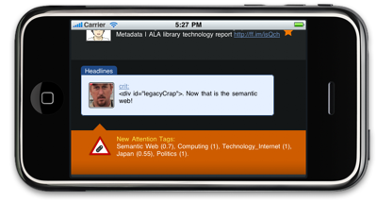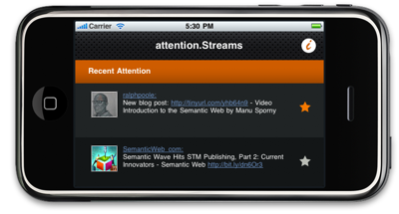

Attention Based Realtime Recommendations
Attention Streams (AS) can be described as a semantic realtime attention tracker. Contrary to usual interest extraction approaches, AS analyses your interests as you navigate between pages. This process is totally transparent to the user since the tracking engine runs as a page background process. AS relies on the OpenCalais API for extracting Attention Tags as you browse the web. The system detects if you are interested in a page and automatically enriches your profile with the fetched tags. Each tag is associated with an attention rate that increases or decreases in realtime.
Attention Streams provides a simple application that uses these tags for querying different online services in realtime given your most important attentions streams. The application enables the user to discover new information based on its interests. Contrary to the existing recommendation services, AS can discovers content that fits the full user context based on his location and attention. AS does not rely on generic interests for finding recommendation but on the evolving interests of the user. As a consequence, AS is providing highly contextual and ambient recommendations that can be used for supporting the user activity. The passive recommendations minimize the explicit user interaction with the system thus avoiding the user distraction: the user can just check the system if he needs specific information since it is always updated with his current activity.
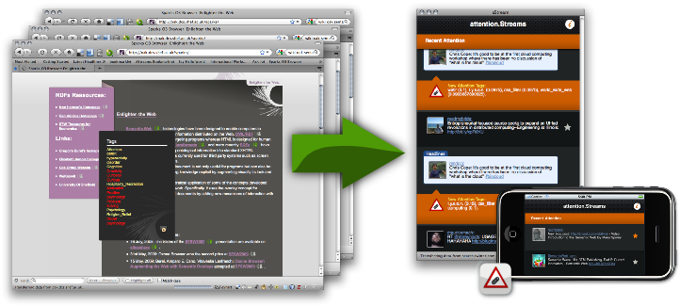

How does it Work ?
The Greasemonkey script extract social tags from the pages you visit and merge back the information to the page itself using RDFa. Then, this information may be used for applying filtering techniques within the page given the user attention tags.
The extracted tags are merged to the a FOAF profile hosted on the application server using the APML RDF Ontology. As the user update his profile, the attention tags values increase or decrease for matching the increases and decreases in his interests. Currently, there is two tag lists differentiating the long therm tags and short term tags.
The retrieved tags enable the adaptation of a user interface by matching the user's tag and the tags within the interface. For instance, it becomes possible to hide irrelevant tagged information or highlight/extend the information that seems to be interesting the user.
In a similar fashion, it is possible to give real-time information recommendations based on the user activity tags. For example, it is possible to retrieve bookmarks, or news that might interest the user right now.
<………….>

More on projects official page: http://nebula.dcs.shef.ac.uk/sparks/astreams

